Sathiyan santhalingam P2606433

College system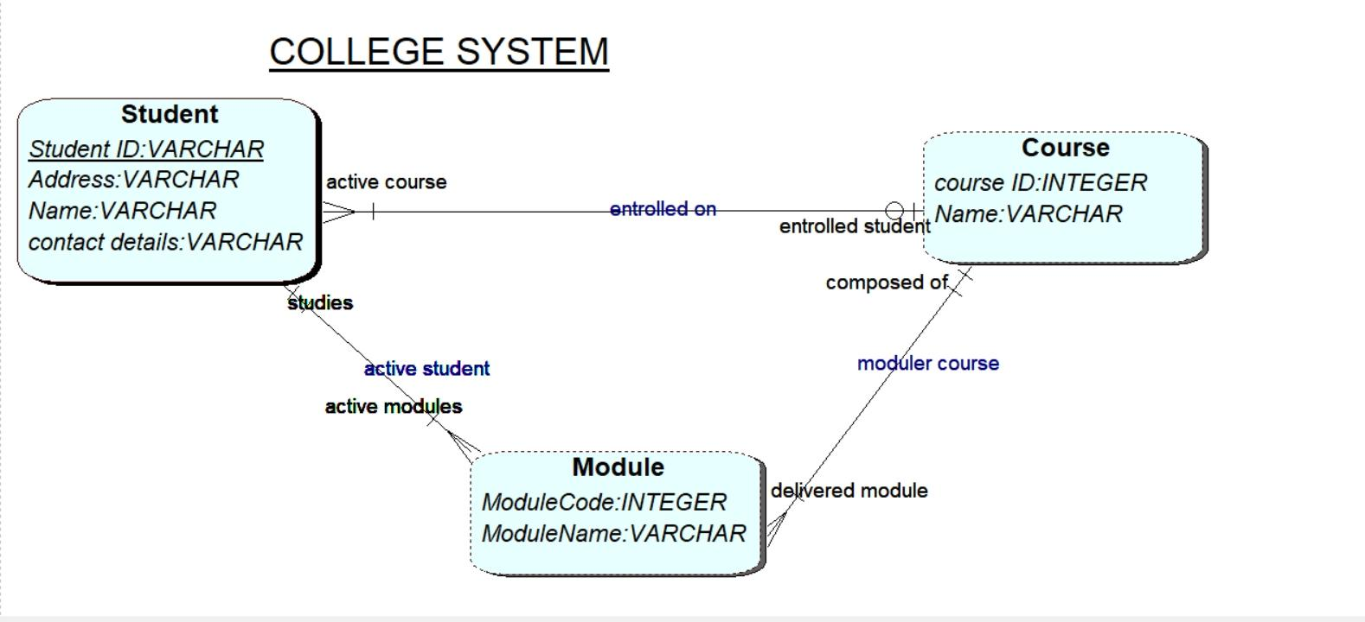

On the following ERD DIAGRAM you can see the following attributes which tells you the college system and the design also student can chose the module and course on the college website and they can able to chose the course which they need and they can enquiry the course problem from the website also they can also view the modules which are though on the website and they can able to register for the course and module leader .